**Introduction to Scilab :**

**Scilab is a programming language associated with a rich collection of numerical algorithms covering many aspects of scientific computing problems.From the software point of view, Scilab is an interpreted language.**

* **Types of operators:**

**1)Arithmetic Operators**

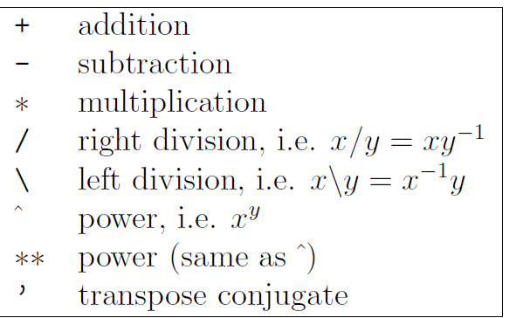

**2)Boolean operators & Logical operators**

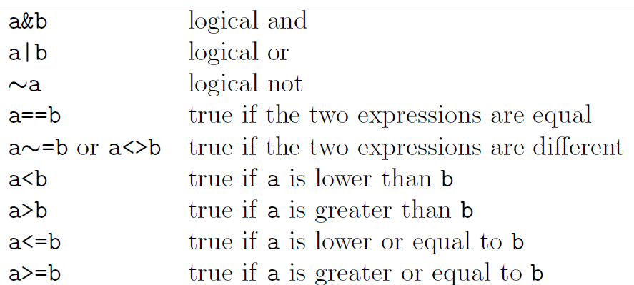

* Integer Variables

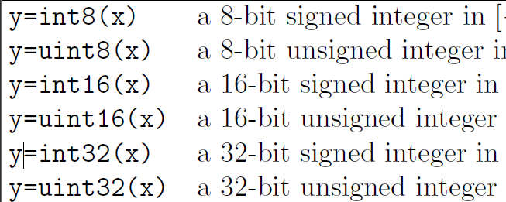

**Practical No .01**

**Set Theory**

1. **A)** Inclusion Exclusion principle

**B)** Power Sets

c) Mathematical Induction

|  |  |
| --- | --- |
|  |  |
|  |  |
|  |  |

|  |  |
| --- | --- |
|  | |
|  |  |
|  |  |